**Parameterized Trigger:**

* We need to install parameterized trigger plugin copy the parameters from one job to another



* If upstream job has a parameter, then the same parameter should be there in downstream job as well to pass the parameters
* We can pass the parameters with any of the below options

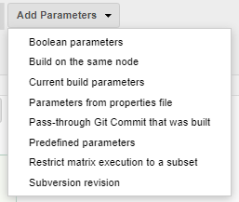

* We can pass the Boolean parameters as below, even if any default value set on downstream job, that changes will be overwritten by this as below

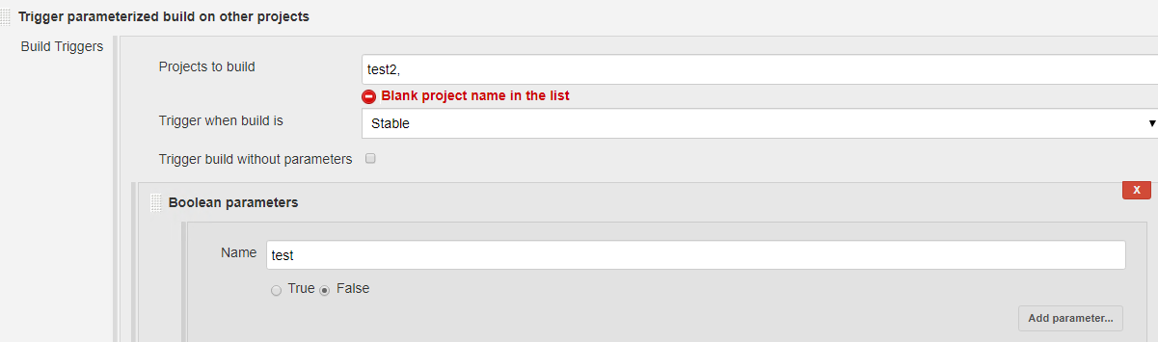

* We can also restrict the downstream job to be triggered in the same node as below

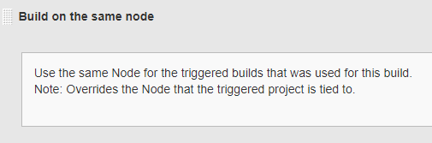

* We can also use “current build parameters” option to copy all the parameters from upstream to downstream, but we must have the same parameters on both the jobs

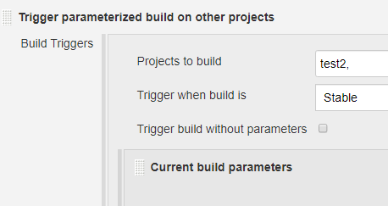

* We can also create a file with parameters and use it as below to copy the parameters to downstream job as below

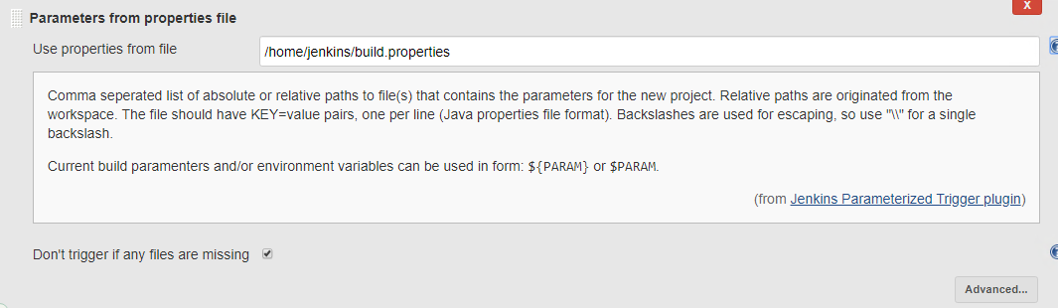

* Finally, we can also able to trigger the downstream job by passing the parameters from upstream as below

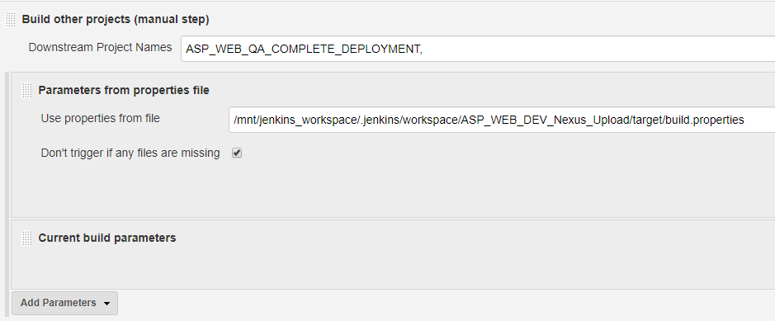

**Parameterized Scheduler:**

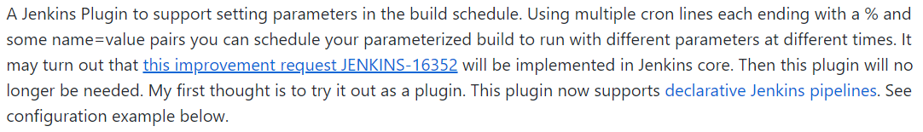

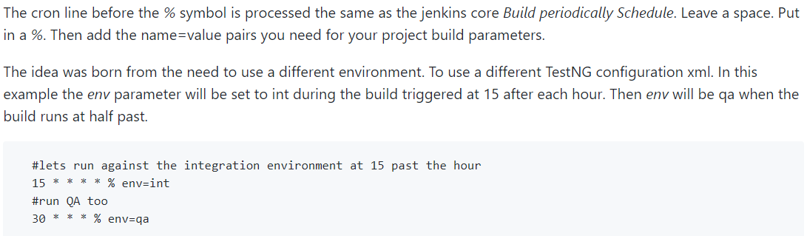

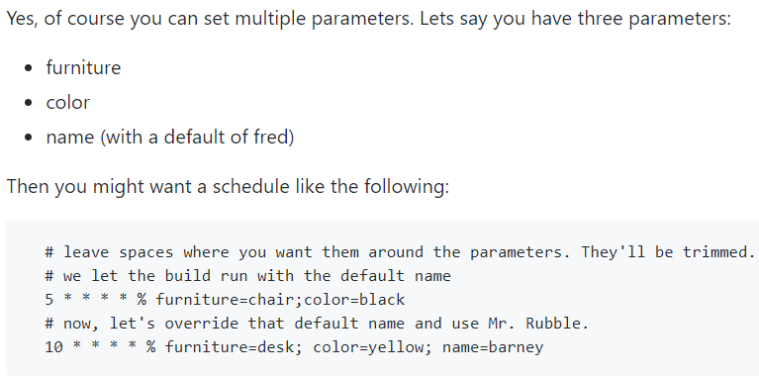

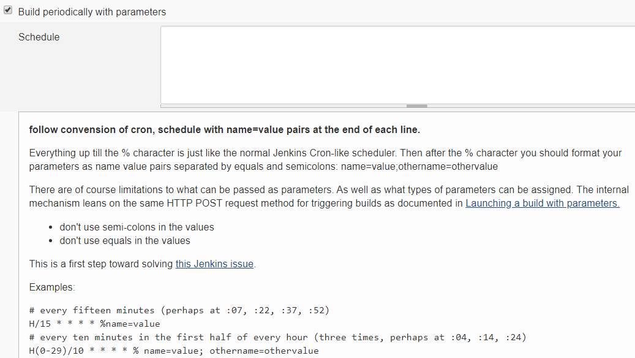

* With declarative pipeline as below

